Quality Engineering Challenge @ GITG

This challenge is designed to evaluate your approach in finding defects within a given product, how you document them, and eventually prevent them from happening again in the future.

**Task 1**

Given you have the following webpage: https://www.bausparen.at/de/bausparen.html.

Using any publicly available browser or web-enabled tools, document and explain how to reproduce each defect you might find on the page. (There is no limit to the amount of defects you can write).

[Link](https://wohntraumrechner.bausparen.at/finanzierungsrechner?utm_source=rbsk-website&utm_medium=navi-2&utm_campaign=wtr&utm_content=link)

The minium number for project cost is 4000 Euro, so I think the number in sliding bar and textbox should be 4000 Euro.

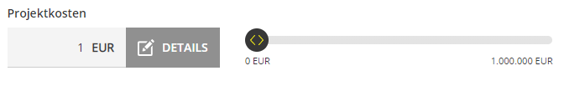



**Task 2**

How would you report the above defects in a tracking system? Pick one and write down all information you think the developers would need to fix it, please include all fields that you would want to report.

1. 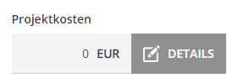

Change default project cost to 4.000 in text box.

1. 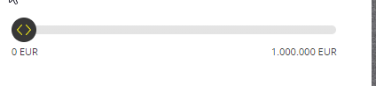

Change default project cost to 4.000 in sliding bar.

**Task 3**

Using a TDD approach, write a regression test plan for the given web page.

Given:

Open [Link](https://wohntraumrechner.bausparen.at/finanzierungsrechner?utm_source=rbsk-website&utm_medium=navi-2&utm_campaign=wtr&utm_content=link)

Default project cost is “4.000 EUR” in textbox and in “DARLEHENSBETRAG”.

When:

Change textbox number to 100.000 EUR ,and press enter.

Then:

“DARLEHENSBETRAG” number changes to 100.000 EUR

**Task 4**

Using the test plan developed above, pick the test cases you consider critical, and automate them using an automation framework of your choice (you can use a template project that is available online).

When finished, please push your solution to a GitHub repo and invite me as a reviewer for your pull request.

Good luck!